Calculating Family Expenses Using ServiceNow
Team Id: NM2025TMID13350
Team Leader: M .RAM KUMAR
Team Member 1: V.PRAKASH
Team Member 2 : L.PRAKASH RAJ
Team Member 3 : M.RAJ KUMAR

Abstract
This project focuses on designing and implementing a Family Expense Management System using the ServiceNow platform. The system enables recording, tracking, and analyzing family expenditures in a structured and automated way. Key features include creating custom tables, defining columns, configuring forms, applying business rules for automation, and establishing relationships between daily and overall expenses.

Introduction
Managing household expenses is often challenging without a proper tracking system. ServiceNow provides a platform to create customized applications that can automate this process. By building a dedicated Family Expenses application, we can:
● Record daily expenditures
● Ensure mandatory expense details are filled  Automate data handling with business rules
● Maintain relationships between daily expenses and total family expenses
This project demonstrates how to leverage ServiceNow’s low-code platform to solve a real-life problem with minimal effort.
Methodology

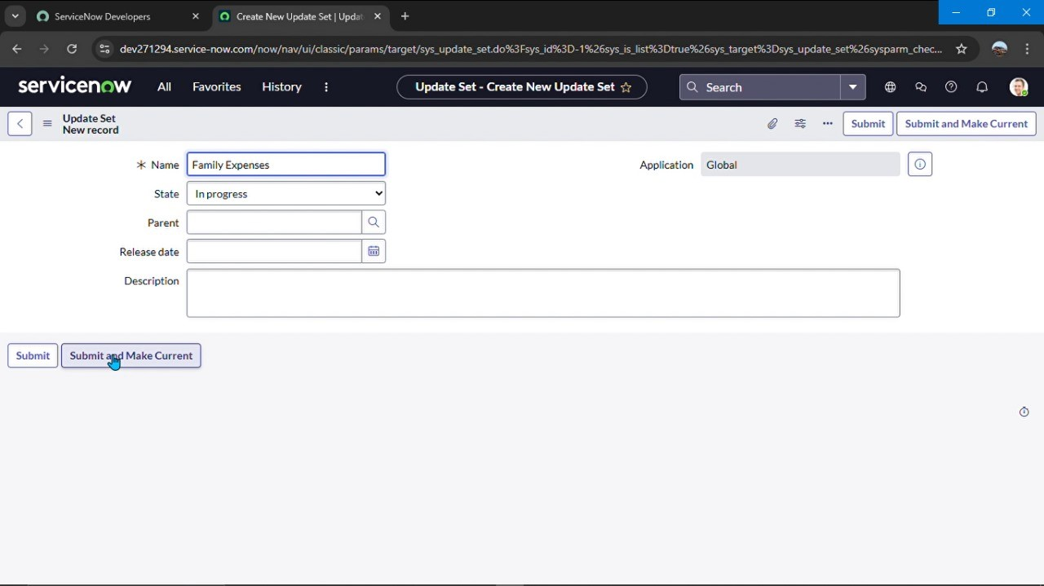
Step 1: Creation of Update Set
Update sets in ServiceNow act as containers to store configuration changes.
● Navigate to All > Local Update set.
● Click New.
● Enter Name: Family Expenses.
● Submit and mark it as Current.
Why? → To track and manage all changes related to the Family Expenses application in one place.

Step 2: Creation of Family Expenses Table
Tables are the backbone of ServiceNow applications.
● Navigate to All > Tables > New.
● Enter details:
● Label: Family Expenses
● Name: Auto-generated  Menu Name: Family Expenditure  Save the table.
Why? → This table stores the overall expense records of the family.

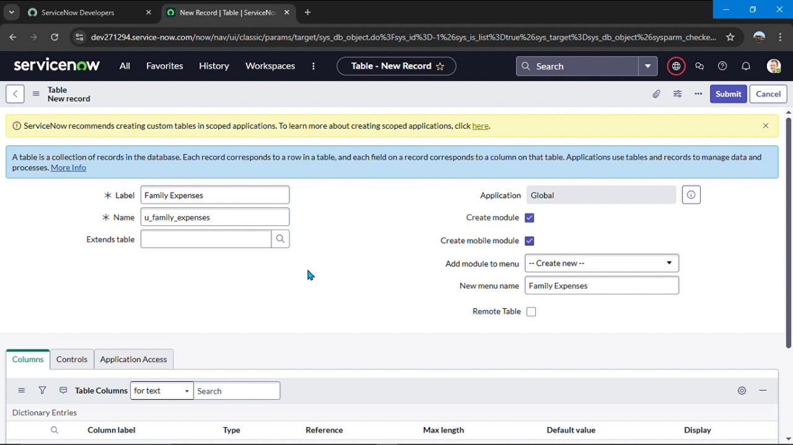
Step 3: Adding Columns (Fields)
Columns (fields) define the structure of the table. For Family Expenses, the following fields were created:
● Number → String (Unique record identifier)
● Date → Date (Expense date)
● Amount → Integer (Total expense amount)
● Expense Details → String (Details/description, max 800 characters) Why? → To capture complete information about each expense entry.

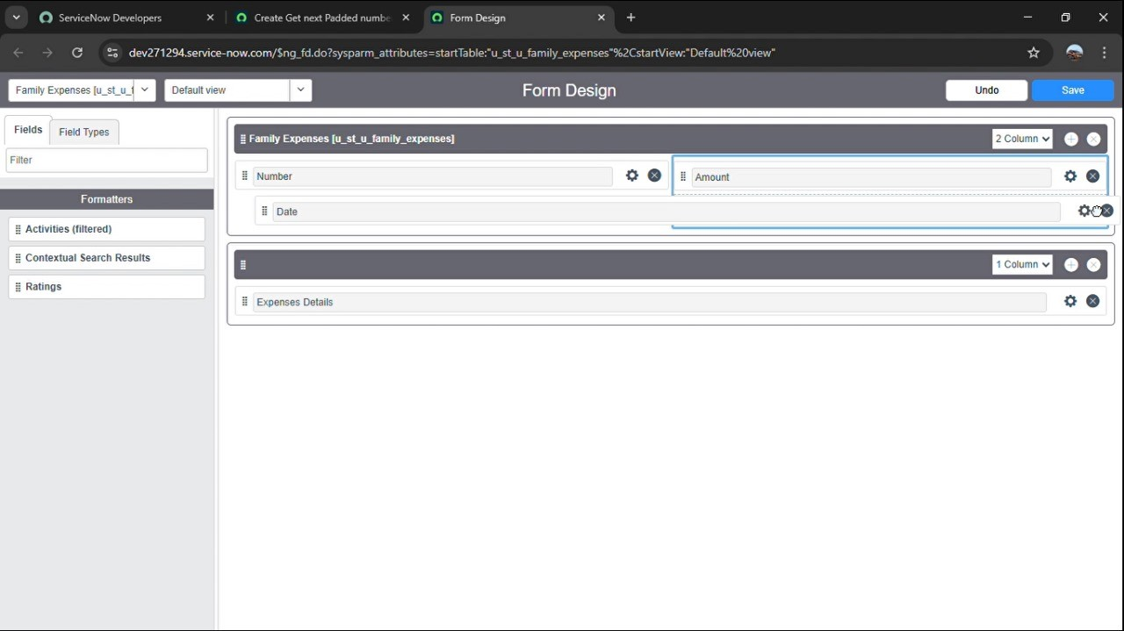
Step 4: Configuring the Form
Forms provide the interface for users to enter data.
● Search Family Expenses in the application navigator.
● Click New → Choose Form
Design.
● Rearrange fields for better readability.
● Make Date and Amount mandatory fields.
● Save the form.
Why? → Mandatory fields prevent incomplete data entry, ensuring accuracy.

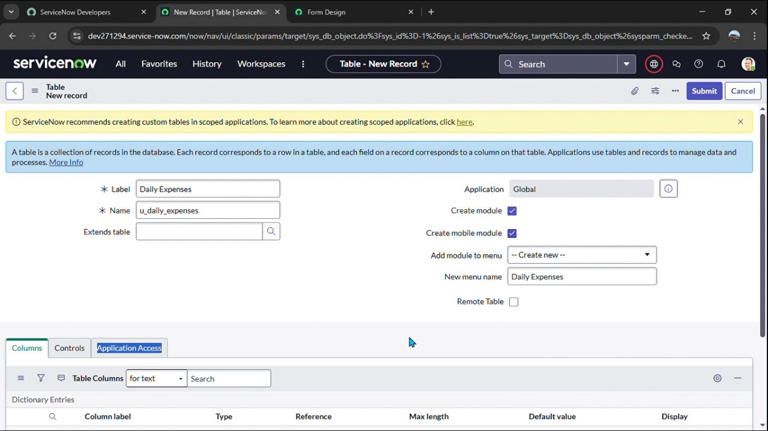
Step 5: Creation of Daily Expenses Table
Daily tracking is important for detailed financial monitoring.
● Navigate to All > Tables > New.
● Enter details:
● Label: Daily Expenses  Name: Auto-generated  Save the table.
Why? → This table captures each individual daily transaction, which can later be linked to the Family Expenses table.

Step 6: Business Rules Implementation
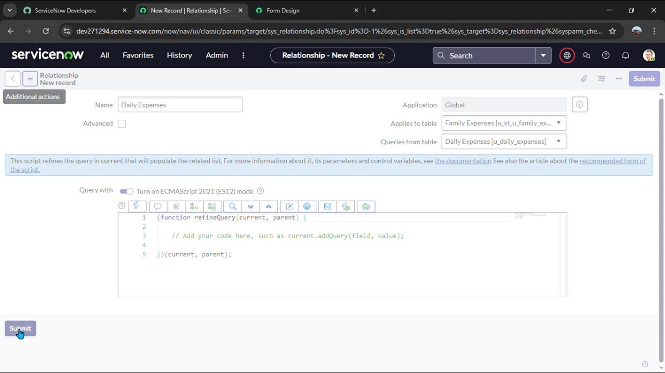
Business rules automate background processes in ServiceNow.
Navigate to All > Business Rules > New.
● Enter details:
● Name: Family Expenses BR
● Table: Daily Expenses
● When to Run: Insert & Update
● Add logic (e.g., automatically update
Family Expenses when Daily Expenses are entered).
● Save the rule.
Why? → Automation reduces manual work and ensures that updates to Daily Expenses reflect in Family Expenses automatically.

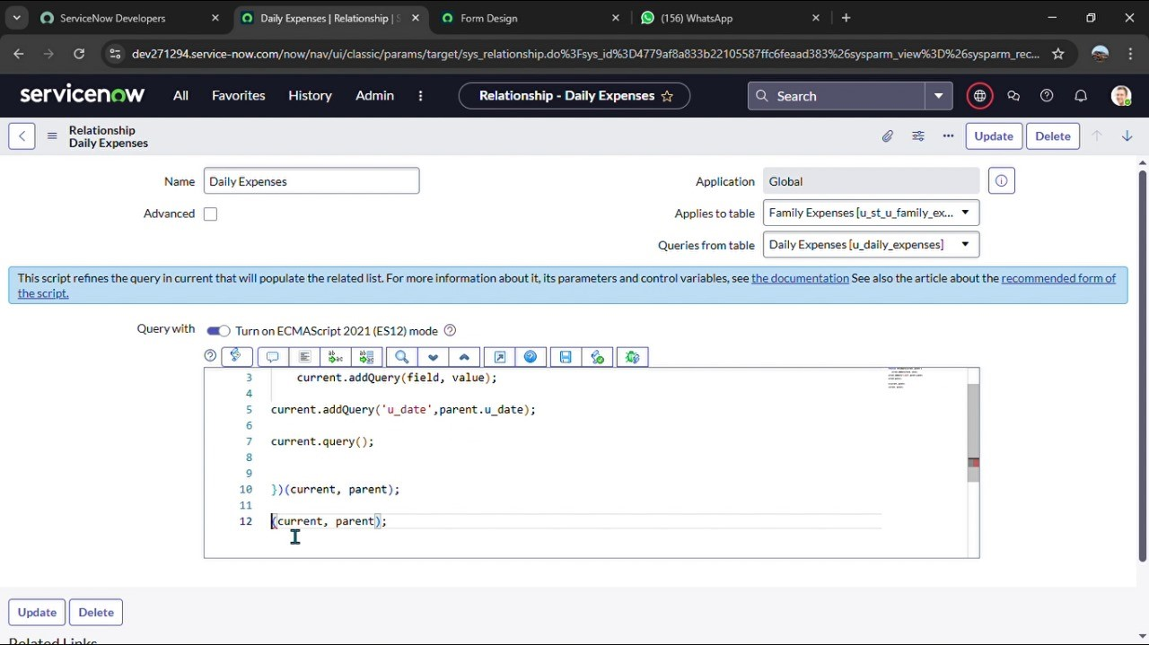
Step 7: Configuring Relationships
Relationships link different tables to make data meaningful.
Navigate to All > Relationship.
● Open Daily Expenses.
● Under Applies to, select Family Expenses.
● Add relationship code and update.
Why? → Establishes a parent-child relationship between Family Expenses and Daily Expenses, making reports and analysis easier.

Results
A Family Expenses table was successfully created.
Users can record daily expenses with details like date, amount, and description.
Forms are configured with mandatory fields to ensure data completeness.
Business Rules automate updates between daily and overall expense records.
Relationships enable linking of data for better reporting.

Applications
● Personal household expense tracking
● Budget planning for families
Can be extended for small businesses or clubs/associations to track group expenses

Conclusion
The Family Expense Management System developed in ServiceNow provides a structured and automated way of managing household finances. By leveraging ServiceNow features such as update sets, tables, forms, business rules, and relationships, the project ensures accurate expense recording, efficient data entry, and improved financial tracking.
This project demonstrates how a simple real-world problem can be solved using the capabilities of a cloudbased low-code platform.

